Configuring Deploy Plugin for Performing Automated CD

Objective: To configure a CI/CD pipeline in Jenkins for deploying a Java application to Tomcat Apache

Step 1: Install Tomcat Apache 9 on Ubuntu

- Open the terminal in your lab and use the following command to switch to the root user:
sudo su

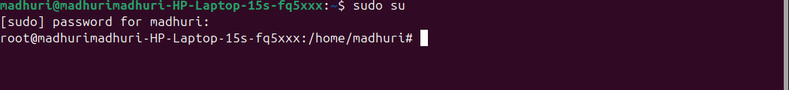

- Install Tomcat Apache and other required packages using the following command:
apt update
apt install tomcat10 tomcat10-admin
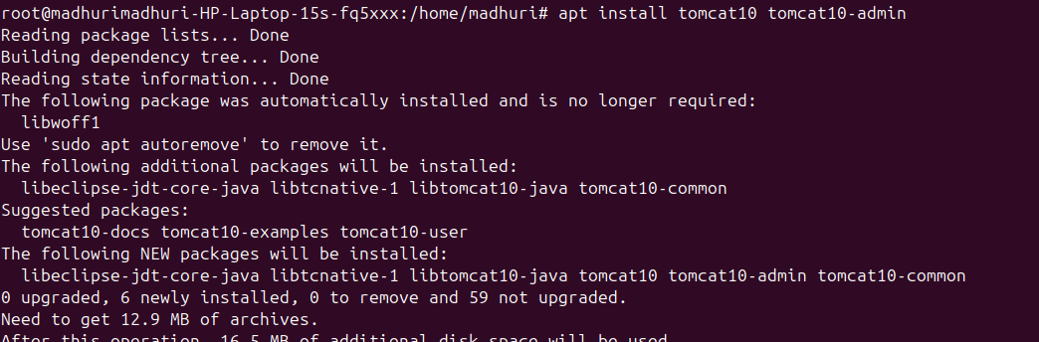

- Once the installation is complete, open the tomcat-users.xml file using the following command:
vi /etc/tomcat10/tomcat-users.xml
Add the following content in tomcat-users.xml file:

<role rolename="manager-gui"/>
<role rolename="manager-script"/>
<role rolename="manager-jmx"/>
<role rolename="manager-status"/>

<user username="admin"
password="admin123"
roles="manager-gui,manager-script,manager-jmx,manager-status"/>

- Open the server.xml file using the following command and scroll down to change the connector port number of Tomcat to 9095:
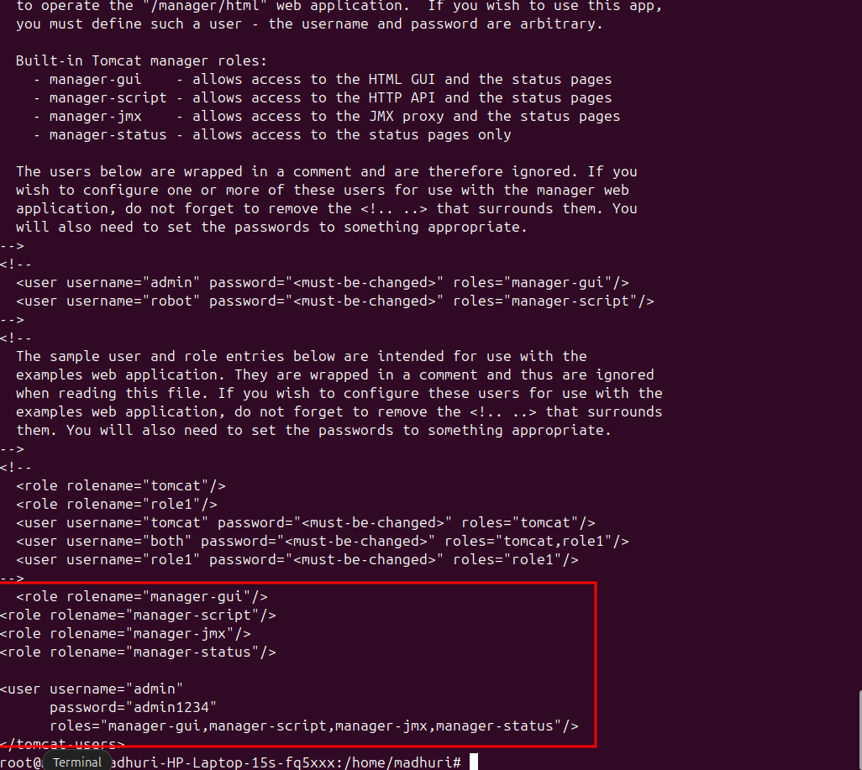

vim /etc/tomcat10/server.xml

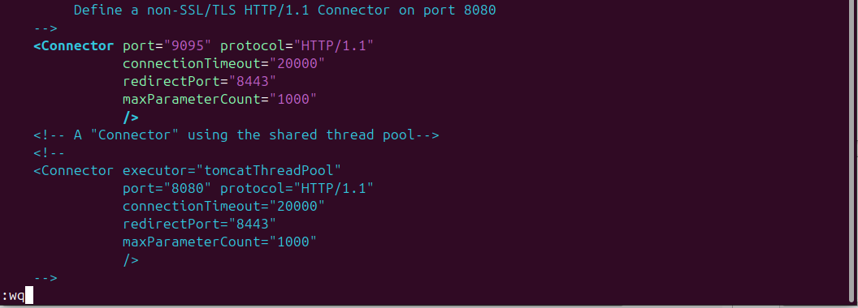

- Restart Tomcat using the following command:
systemctl restart tomcat10

Navigate to localhost:9095 in your web browser and access Tomcat
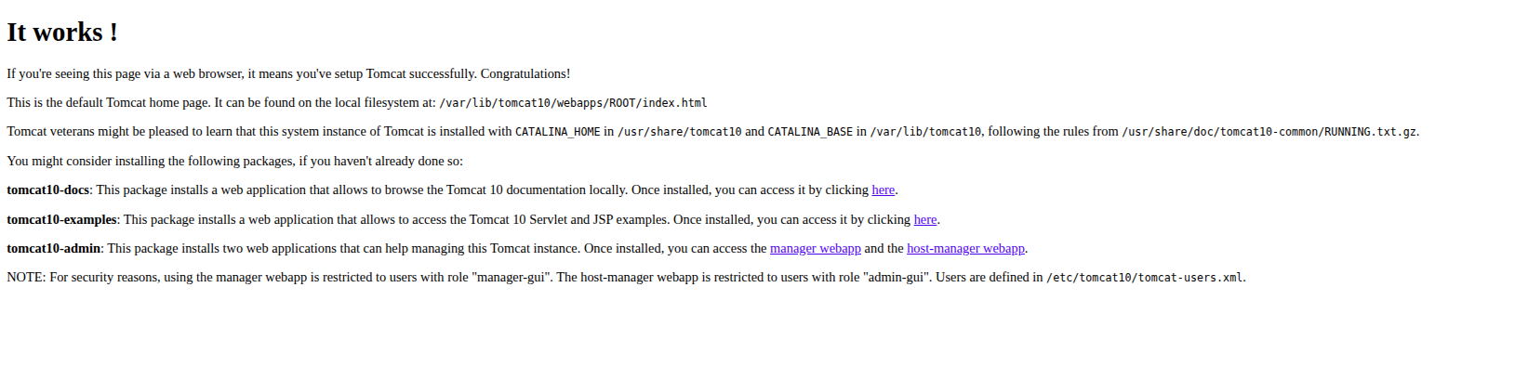

- Click and access manager webapp to make sure the Tomcat setup is complete

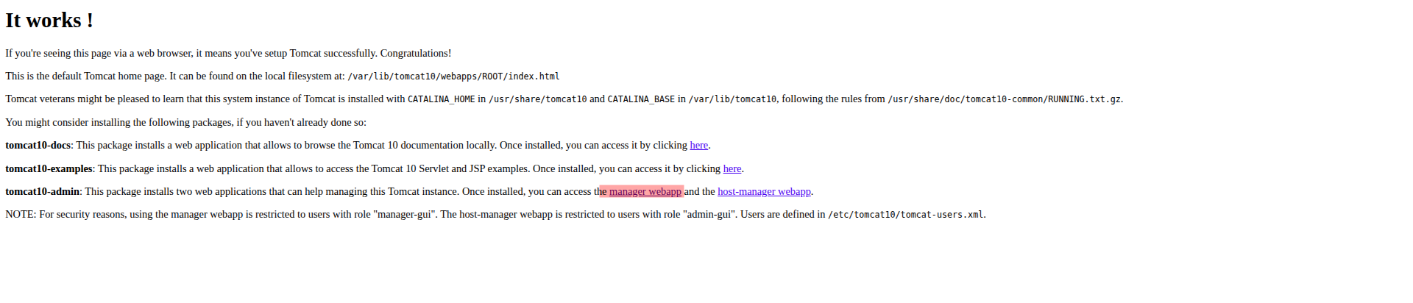

- Enter the credentials and click on Sign in
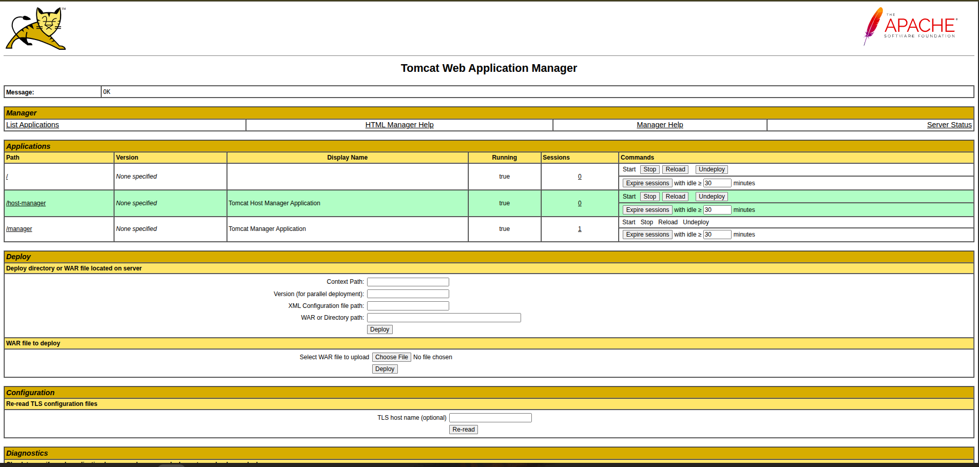

Step 2: Log in to Jenkins CI tool and install Deploy to container plugin

- Navigate to localhost:8080 in your web browser, enter your credentials, and click on Sign in
Click on Manage Jenkins on the Jenkins dashboard
Scroll down and click on Plugins under System Configuration
Navigate to Available plugins and search for Deploy to container plugin
Select Deploy to container plugin, click on Install
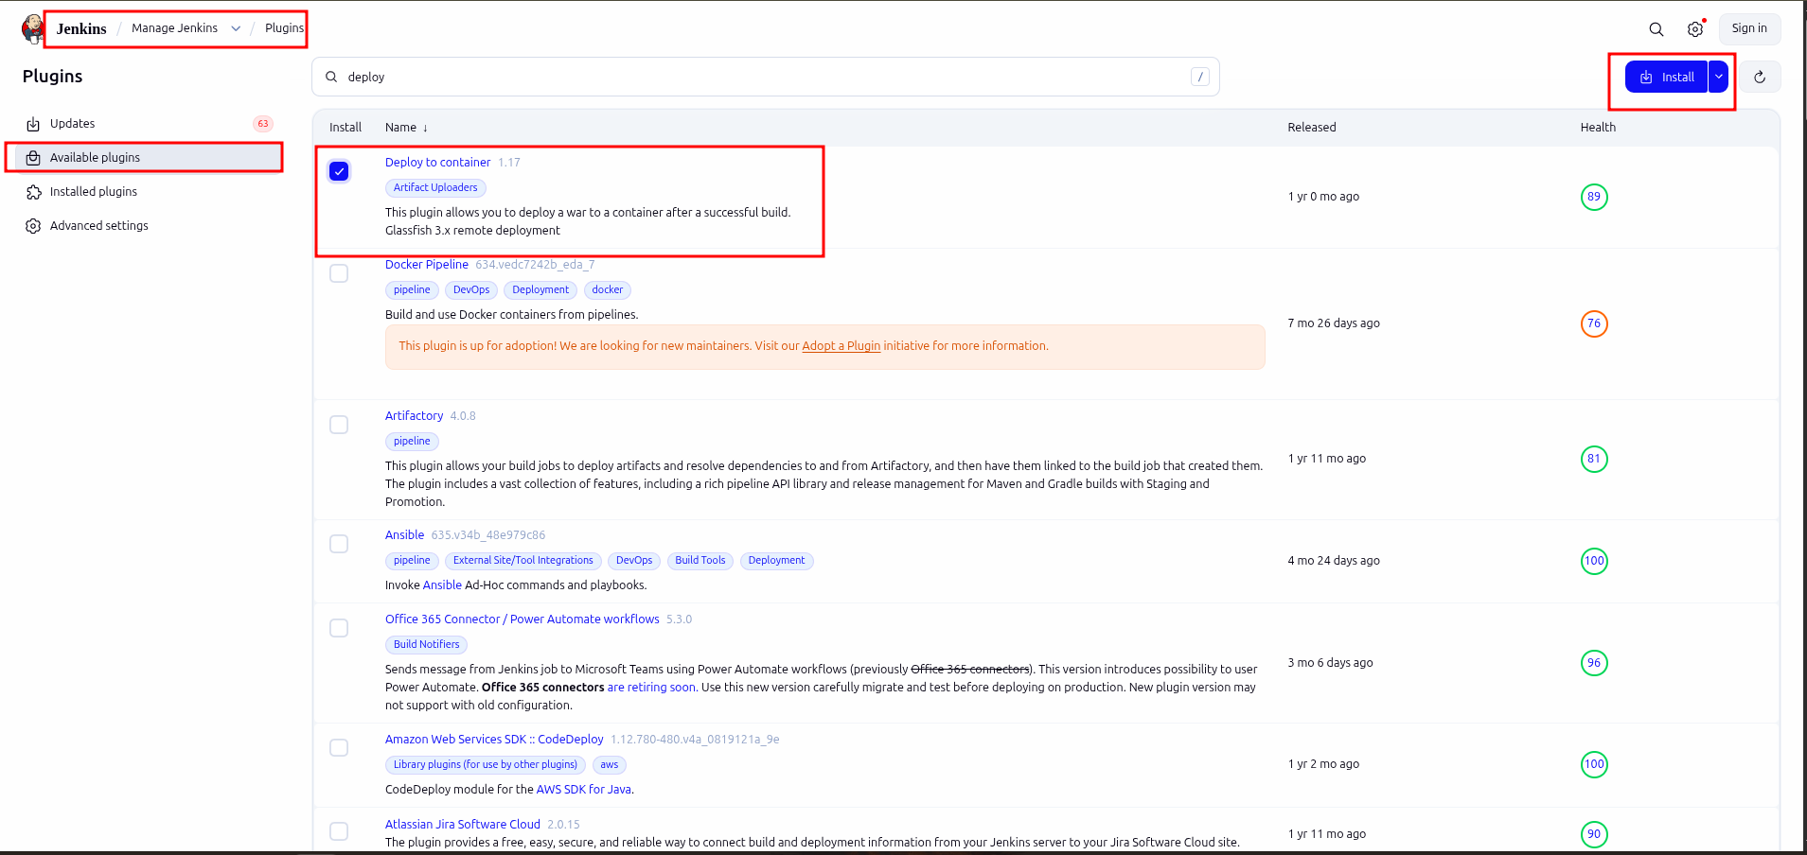

- After installation, navigate to the following URL to restart Jenkins:
http://localhost:8080/restart

Step 3: Configure the deployment stage in the Jenkins pipeline

- Enter your credentials and Sign in to Jenkins CI tool
Click on New Item to create new Jenkins job
Select Freestyle project while creating Jenkins job and provide a custom job name, then click on OK to continue

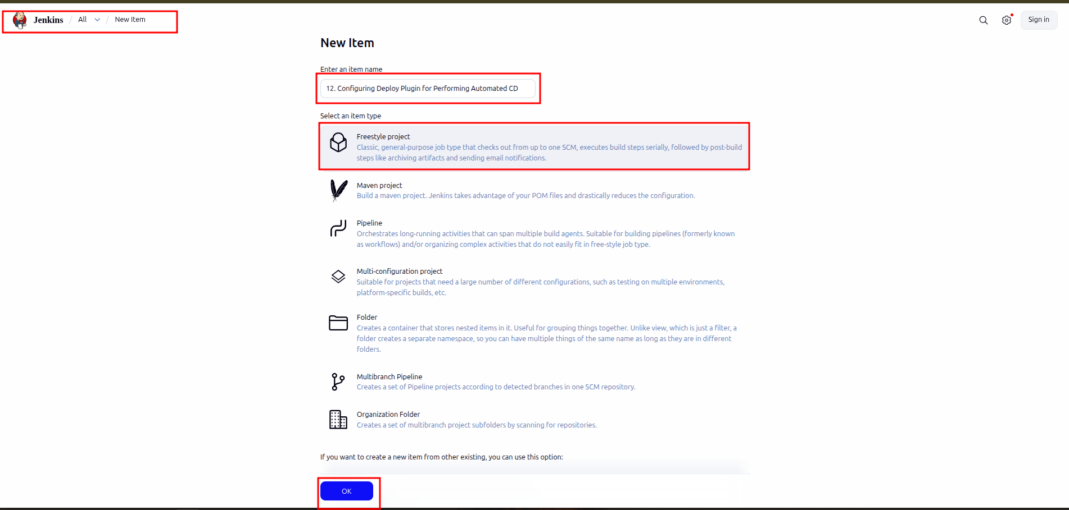

- Go to Source Code Management and select Git
Enter the following Repository URL:
https://github.com/anujdevopslearn/MavenBuild.git

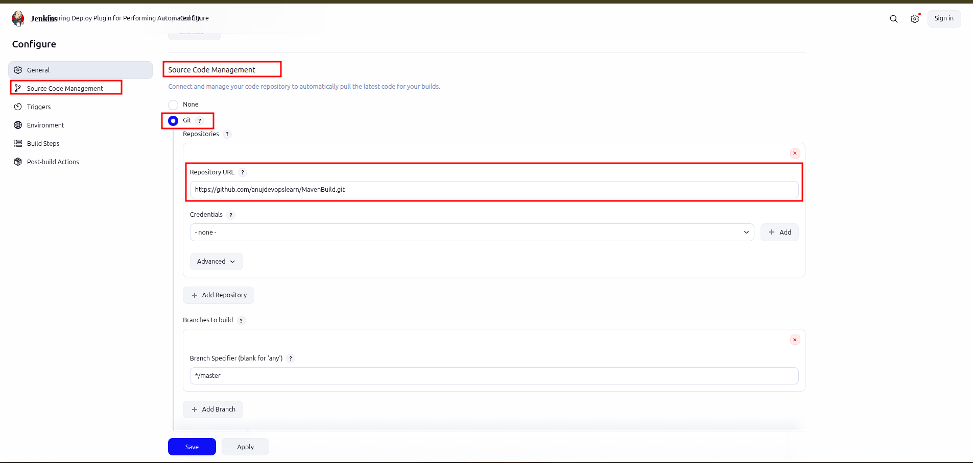

- Go to Build Steps under Configure:
Click on Add build step and select Invoke top-level Maven targets

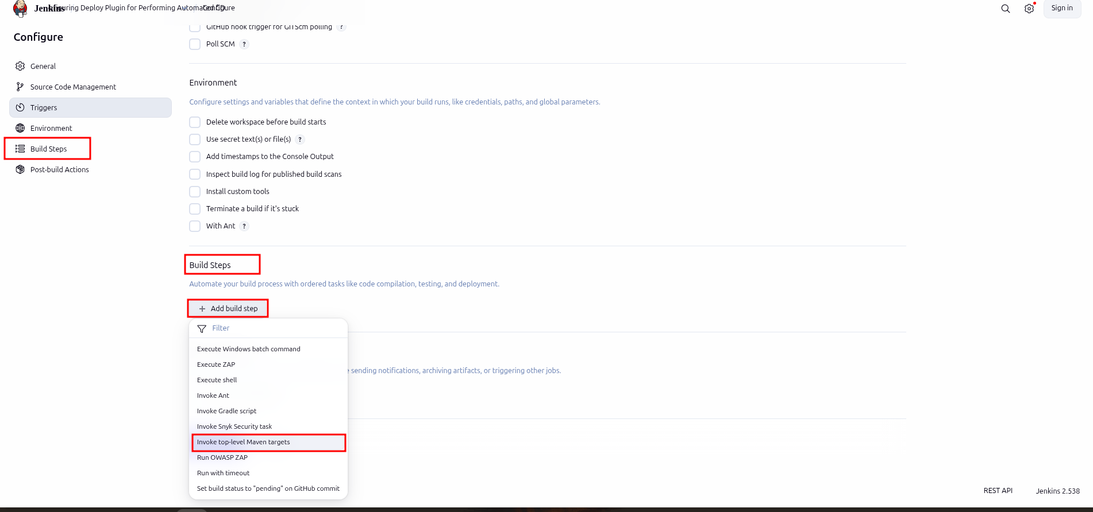

- Enter the following Maven Version:
Maven
Enter the following Goals:
clean install
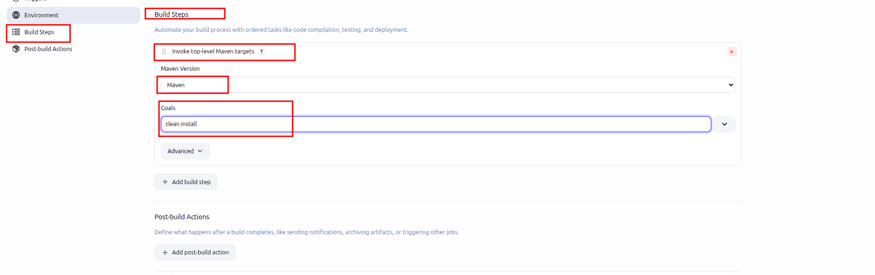

- Go to Post-build Actions
Click on Add post-build action and select Deploy war/ear to a container
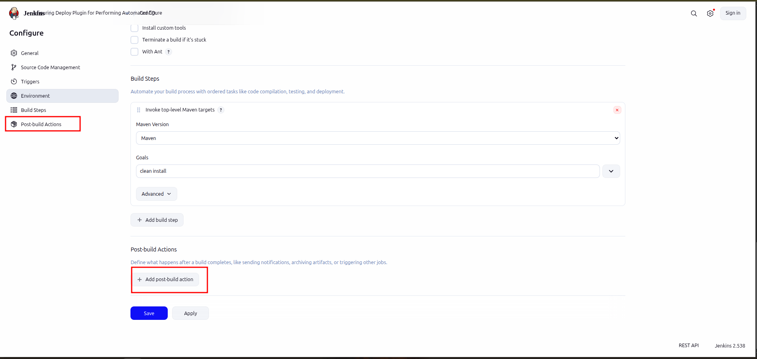

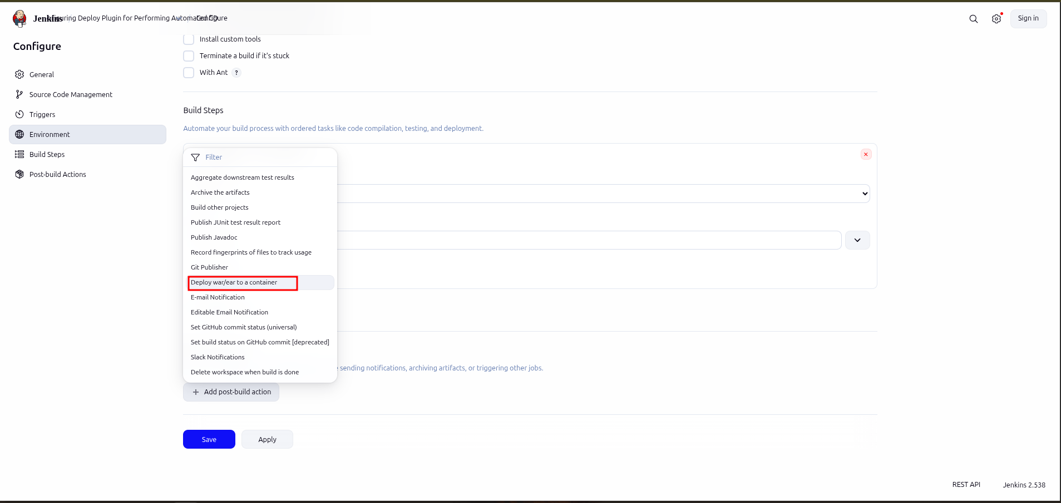

- Enter the following path under WAR/EAR files:
target/*.war
Click on Add Container and select Tomcat 9.x Remote

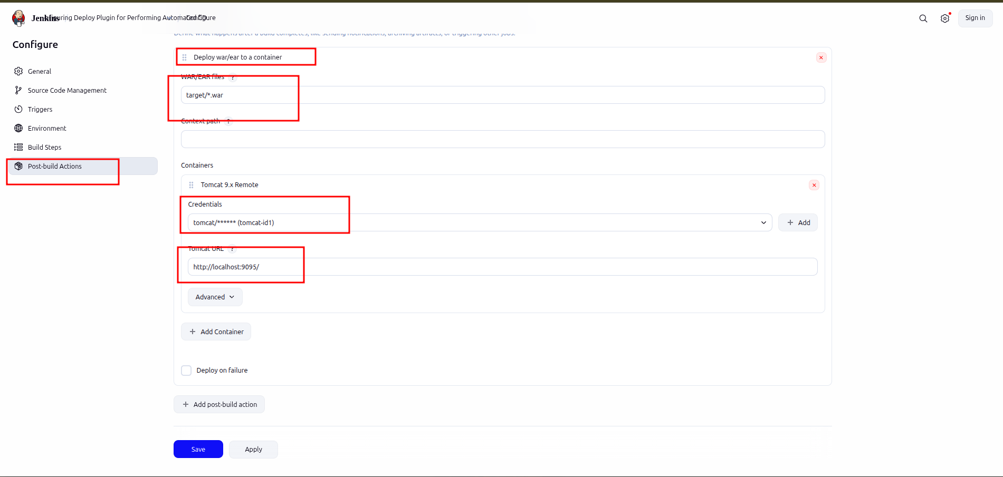

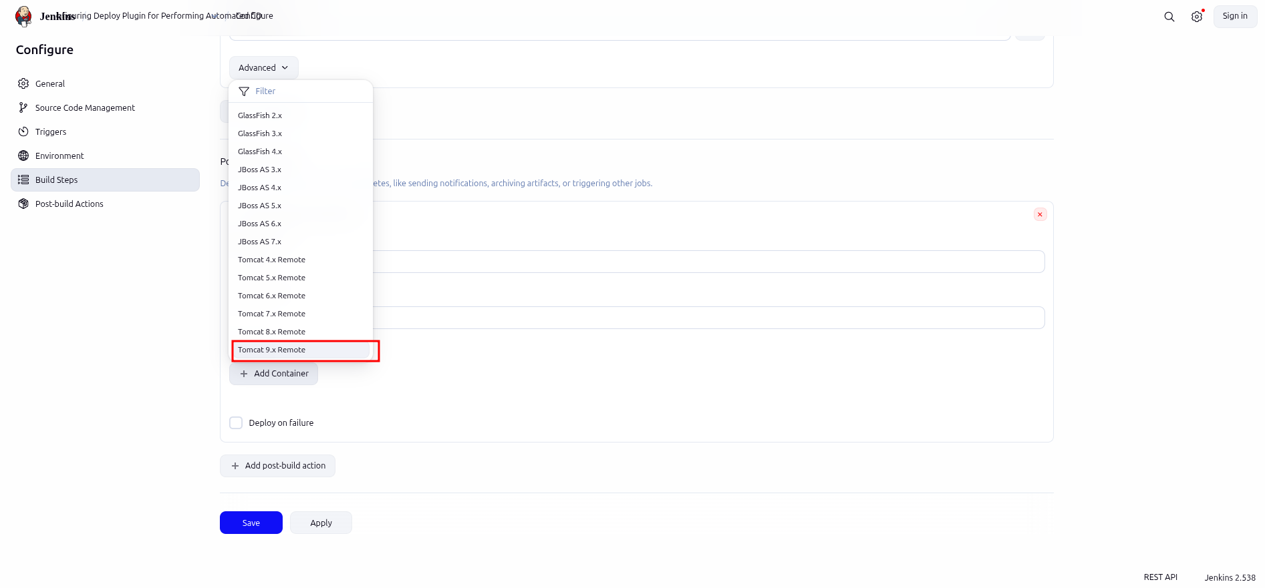
- Click on Add under Credentials and select Jenkins to add the Tomcat credentials
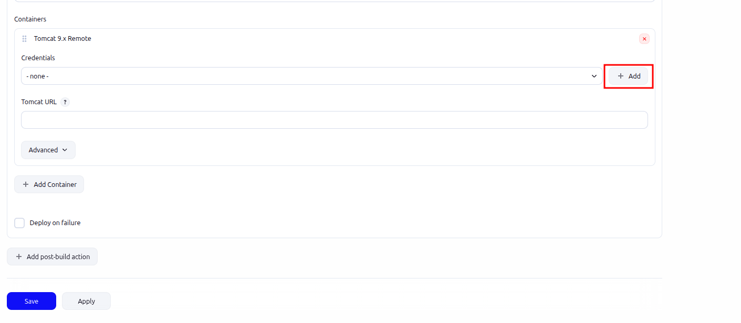

- Scroll down and enter the following details:
Username: admin
Password: admin1234
ID: tomcat-id
Description: tomcat-id

Click on Add to save the credentials

in the Credentials dropdown menu, select the added credentials

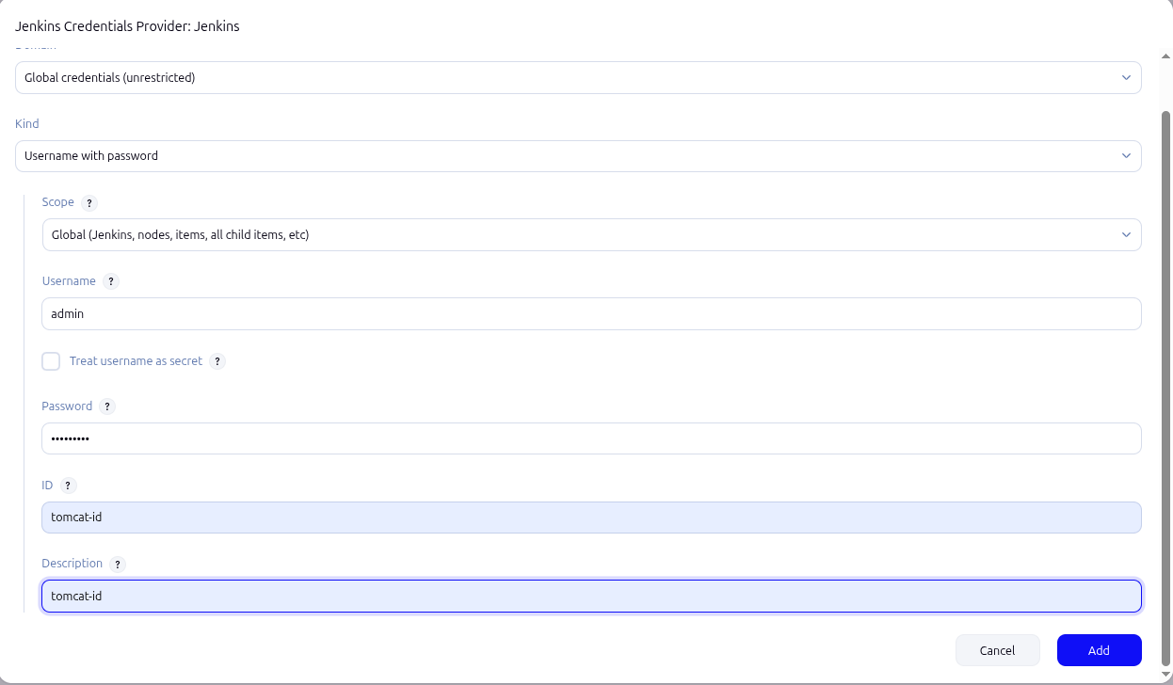

- Enter the following Tomcat URL and Save the job:
http://localhost:9095/
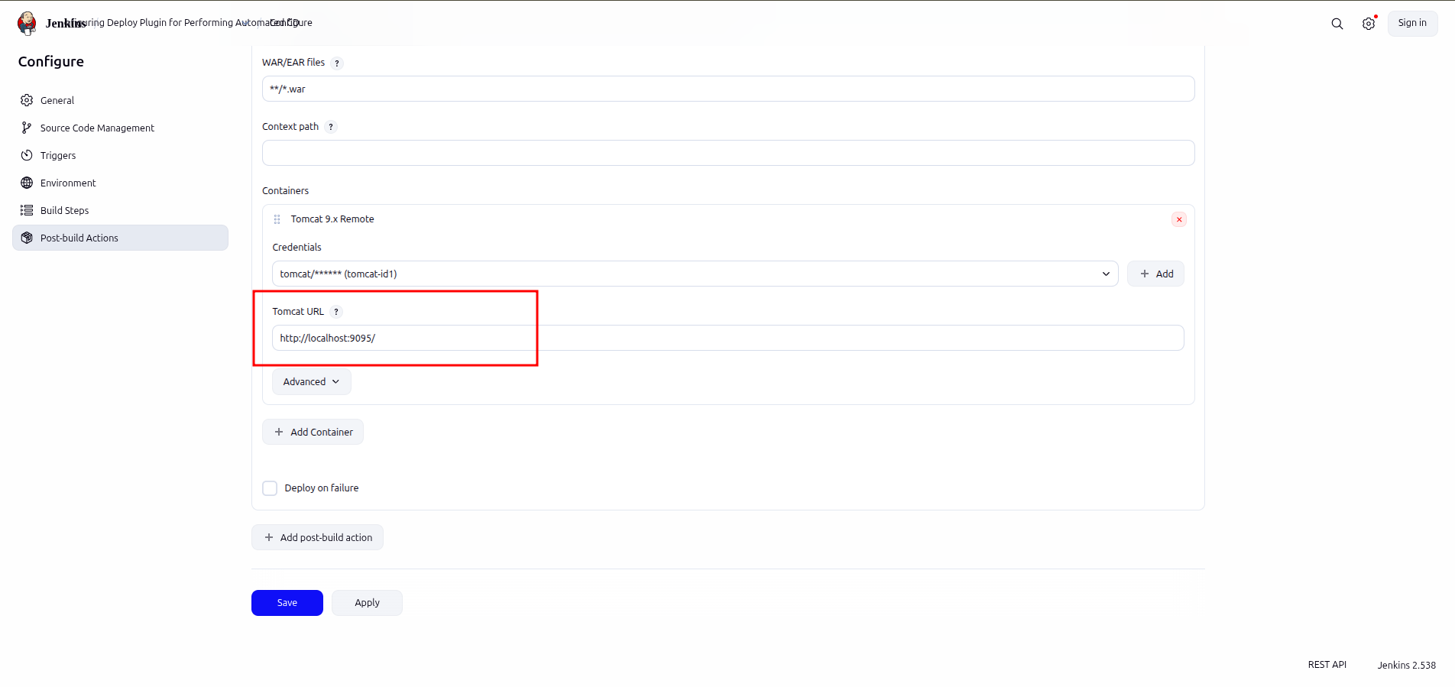

- Click on Build Now and then select Console Output to check the output

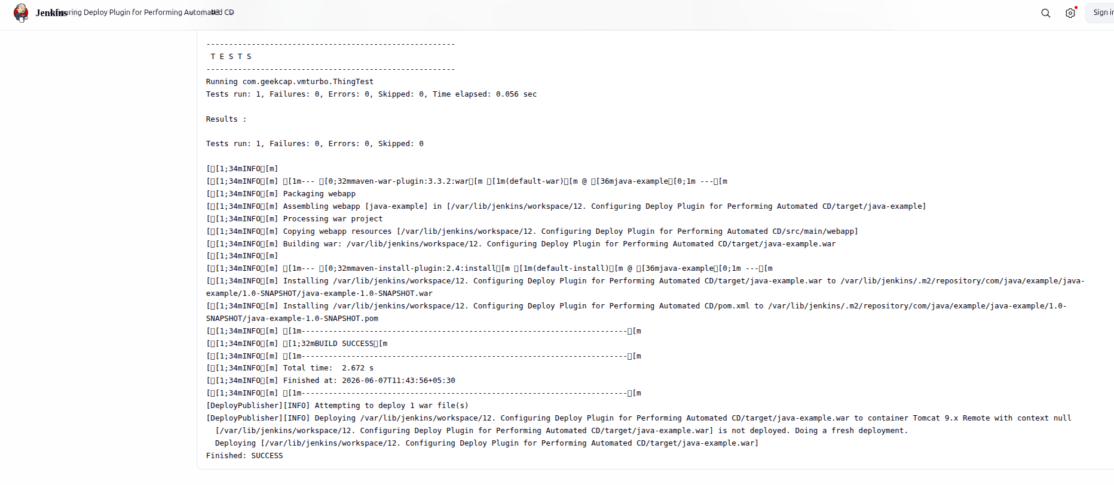

- Access the deployed application in your web browser with the following URL:
http://localhost:9090/java-example/

